**BERMUDA**

The purpose of this report is to highlight the events and activities of our class here in Bermuda for the year 2020.

However, this report will be brief as the racing and regattas were severely restricted by the Covid world pandemic.

I was elected as the president at our class AGM in January this year. The slate of officers elected included,

Vice President Mathew Cairney

Treasurer Sacha Simmons

Secretary Greg Lawrence

Ex Officio

Social: Jean-Lou Pengelly &amp; Amy Pengelly

Technical: Robert Duffy

Sailing Events: Richard Thompson

Ex-President: Patrick Cooper

Member at Large: D’Arcey Betschart

Member at Large: Craig Davis

Over the winter we had hauled out 7 IODs and were able to store them in member Michael Richold’s yard. As he is an IOD owner he graciously allowed the class to store our IODs there at no charge. Encore had been severely damaged by hurricane Humberto and was an insurance write off. Bob Duffy kindly donated her to the class and it was felt that she could be rebuilt and made ready for the 2020 season. There was good class support this project and Craig Davis led the charge.

We were looking forward to another active season of IOD racing. These included the Bermuda Match Racing Nationals, the Bermuda International Invitational Race Week, the Argo Gold Cup, Bermuda Keelboat Nationals, the North American Championships. We began sending out invitations for the 2020 Bermuda International Invitational Regatta. Rick Thompson does a stellar job with the organizing of this regatta. It has always been a popular event for

international IOD sailors and there are usually 12 overseas teams participating. This regatta would then roll right into the Argo Gold Cup, part of the World Match Racing tour. Negotiations with the organizing committee for the event were well underway.

At the beginning of March we held the Bermuda Match Racing Nationals won by Kelsey Durham. He was to go on to represent Bermuda in the forthcoming Argo gold Cup.

However, by the second week of March the effects of Covid 19 virus were really taking hold in Bermuda and around the world. Borders were closing and regattas were being cancelled along with other sports events. It was decided by the executive that we should cancel the Bermuda Invitational Race Week and Rick Thompson informed all those who had entered.

The IOD Class executive held our first Zoom meeting in April and it was very well attended. The Argo Gold Cup was rescheduled for October 25 th -30 th . The Bermuda Team Racing regatta scheduled for October was cancelled. The North American Championship scheduled for November was postponed till 2021 with a date still to be decided.

Covid 19 has had an enormous impact on every ones lives and yacht racing in Bermuda along with all sports events and public gatherings were cancelled. Cup Match, a very popular spectator event when one end of Bermuda plays cricket against the other end of the island was also cancelled.

August and September saw Wednesday night sailing return with several IODs participating. However there were still 5 or 6 IODs on the hard stand at Michael Richolds yard having work done in preparation of Gold Cup. The Argo Gold Cup was able to proceed in October with considerable Covid 19 protocols in place. This turned out to be a very successful event moderated by Tucker Thompson and won by Taylor Canfield. There was very good international coverage putting Bermuda in the spotlight as a Covid free destination.

However, it was not without incident and there were 3 bow chocks that needed replacing.

The Bermuda Keelboat Regatta on November 22, 23, and 24 th had 7 entries for the event but 1 team declined as the weather forecast was 18 knots gusting 25. With 6 teams on the water we still had 9 good races over 3 days despite heavy weather for the first 2 days. Patrick Cooper won followed by Blythe Walker and Craig Davis. The results can be viewed on the Regatta Network site on line.

This is a summary of our limited IOD events for this year and it is hoped that Bermuda will host the IOD North Americans on a date still to be decided.

I very much hope that life and IOD racing will get back to normal in 2021.

Respectfully submitted.

Kevin Horsfield, Bermuda Fleet President

**CHESTER IOD 2020**

This year started with high hopes and great expectations for the Chester IOD fleet as we had signed on to host the IOD Worlds in September. Preparations were under way and the boats worked on to ensure they were at their best. New mains were ordered, and our other sails checked to make sure they were evenly matched for the regatta.

February came and the first cracks in our plans started to appear! The beginning of the worldwide pandemic dominated the news headlines. It soon became clear a major uncontrollable event was to dominate the world, the people, the economy and the politics! By mid-March countries were closing their borders, quarantine became the most used word in our vocabulary, and we learned two new words: Coronavirus and COVID-19! Those words would dominate our conversations for the next 9 months. In Bermuda, we had already made the decision to cancel the annual Bermuda International Race Week. With lockdowns and flight restrictions into the Island, it was clear that it would be impossible to hold this Spring regatta. This would be the first of many cancelations of IOD fleets’ regattas worldwide! In Chester, we agonized over what would be the correct path for us regarding hosting the IOD Worlds. We gathered as much information as was available at the time, all of which pointed to Chester having to cancel the Worlds. Reluctantly, we informed the WCA of this decision and in hindsight it proved to be the correct one.

Months went by as the Nova Scotia Government and the Nova Scotia Sailing Authority wrestled over social distancing, numbers of people in a boat etc. Finally, they put together some guidelines and sailing in Mahone Bay began. Our fleet is made up of two types of owners: the first is local ownership and the other is what Maritimers call “Come from away!” In the Chester IOD fleet the split is 50/50 as half the fleet is local and the other not. The coronavirus had an immediate effect on fleet participation as us “Come from away” owners were prohibited from entering the Maritime bubble. The local IOD owners quickly grabbed the opportunity to go sailing and immediately turned out for the PHRF racing in Chester on Thursday evenings and weekends. This continued throughout the summer and Peter Wickwire found success in winning 2 of the Thursday evening series. The normal turnout for these races was a complement of 6 IO’s which shows how hungry they were for some competition.

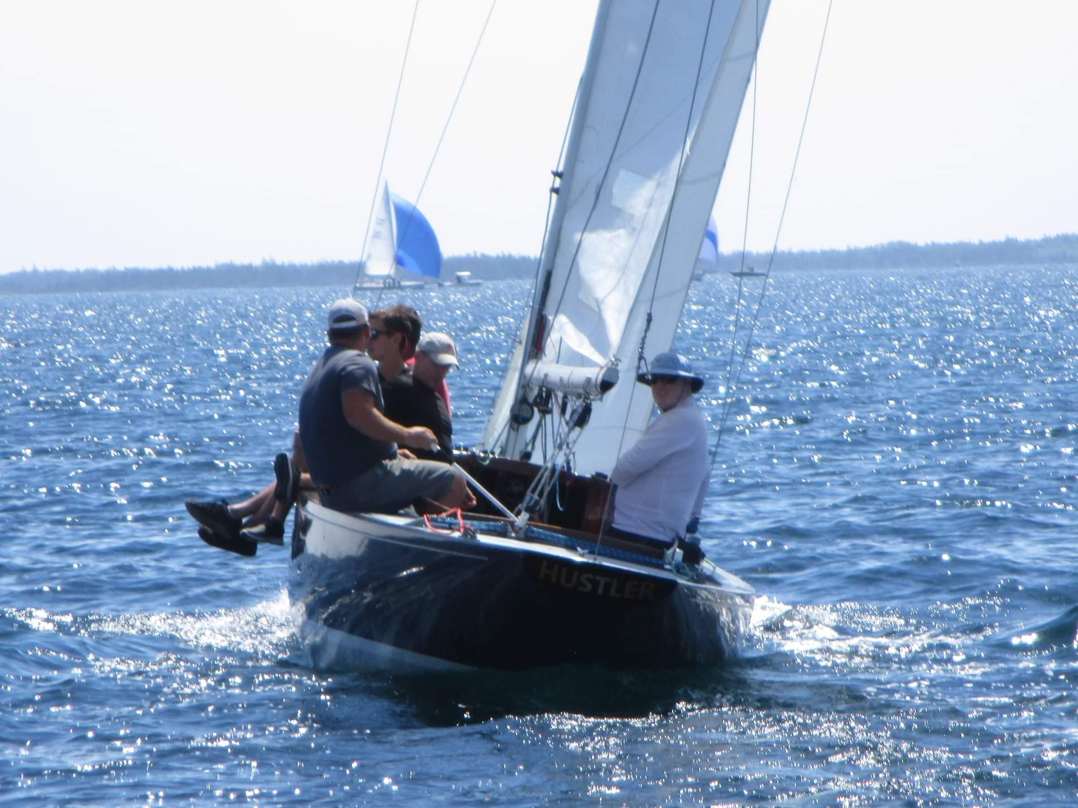

Photo: Ivan Fitch, International One Design

Our Fleet was able to get in two One Design regattas during the summer. The first was hosted by the Chester Yacht Club in early August. Under clear skies and fair winds, Peter Wickwire in Squall prevailed beating out Evan Petley-Jones, with new boy on the block Ivan Fitch in Hustler finishing third. Hustler is the renamed boat that Ivan and Casey bought from Timmy Dittrich. They are loving it!

The second One Design regatta was hosted by the Lunenburg Yacht Club and appropriately called the “Welcome Back Regatta”! Six IODs turned out for this event and the race was hotly contested as usual. This time Evan Petley-Jones beat out Peter Wickwire by a single point with Ivan and Casey coming in third place.

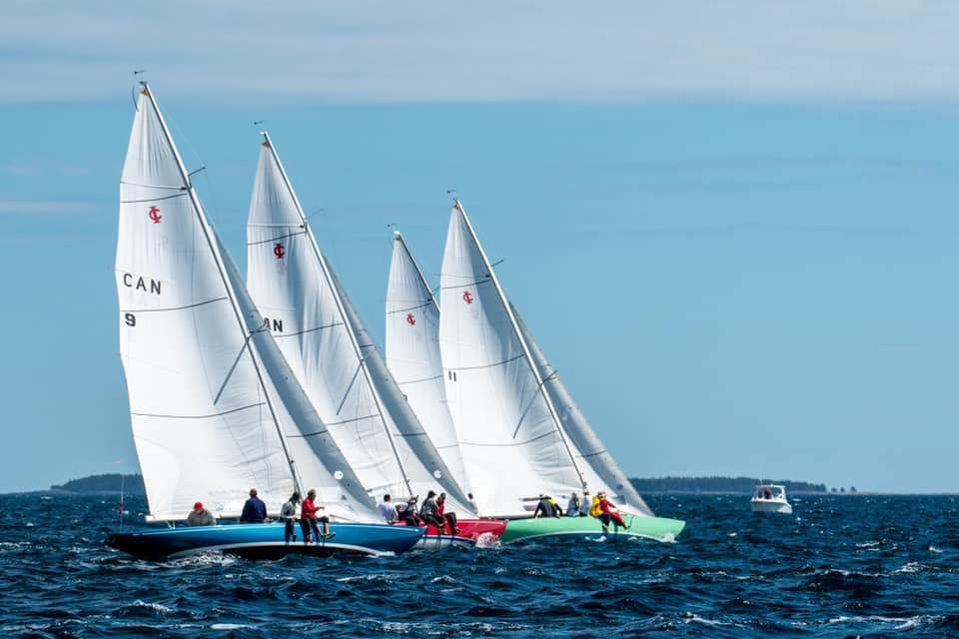

Photo: Lunenburg Yacht Club

The Summer wound down as Fall approached but the enthusiasm for racing continued in the PHRF races until early October. All this to say this year was certainly the most challenging we have faced but our owners and members adapted to the new norm and made the most of it by participating in as many races as that they could. I expect more of the same for 2021 but we now know what we are dealing with and the unknown has now become known. Hopeful the borders with the Maritimes will be open and all of us “Come from away” folks will be able to get back on our IODs and enjoy the sailing and comradery that is Chester and Mahone Bay.

Respectfully submitted

Richard Thompson

Chester Fleet Captain

**FISHERS ISLAND 2020**

Summer 2020 was a challenging—but fun and fantastic—summer of sailing  
for the IOD fleet.  We sailed on weekends from June 27 through to (and  
including) September, racing both short-course and navigator-style  
races.  The fleet was assisted on many weekends by Bill Reed as race  
committee; on weekends when Bill was not on the water, the fleet set  
their own courses and ran their own starting sequences via radio.

Racing this summer were Allegra, sailed by Kip Williams; Creole,  
sailed by Matt Burnham; Ginch, sailed by Wes Maxwell; Golf, owned by  
Bill Reed; Jester, sailed by Charlie VanVoorhis; Nor’wood, sailed by  
the Burnham/Parsons/Rugg/Scholle syndicate; Sirius, sailed by Brad  
Burnham and family; and Zallee, sailed by the Farrars and McNamaras.  
Only two of our normal fleet—Celerity and Duchess—were not launched.  
  
The IOD fleet’s goal for Summer 2020 was to have a lot of fun and to  
maximize participation, both at our informal FIYC racing and at local  
Fishers Island Sound racing.  IODs raced in the Donzo Wednesday night  
MudHeads’ racing series, the MudHead Benefit Cup, the Mason’s Island  
Yacht Club Regatta, the Ram Island Yacht Club ‘Round Island Race, and  
the FIYC ‘Round Island Race.  Racing was competitive and  
action-packed, despite many teams sailing short-handed due to COVID  
restrictions.  Fleet communication was enhanced by a fleet-wide  
WhatsApp chat that enabled sharing of race courses, photos, and  
merriment.

Fall 2020 will brought some of the world’s best sailors to the FIYC:  
Taylor Canfield and Mark Buckley’s Stars and Stripes America’s Cup  
team are coming to Fishers Island, hosted and coached by Jonathan  
Farrar, using Creole and Zallee.  Stars and Stripes also was  
coached by match racing legend Dave Perry.  The team was training for  
the Match Racing World Championships which was held last week during the  
Argo Gold Cup in Bermuda. Stars and Stripes won the match racing world  
championships. We anticipate their return next year.

Jonathan Farrar

**LONG ISLAND SOUND 2020**

For the Long Island Sound Fleet, the 2020 season disappointingly did not take place due to the pandemic.  We have 5 boats in the fleet, Goldilox (Jennifer Miller), Nefarius (Jim Bishop, Elliott Wislar), Elation (Vin Marshall), Makai (Phil Kennedy, John Evans) and Dark Horse (Zach Horton).  We are all looking forward to (fingers crossed) having a more normal season in 2021.

Jennifer Miller

**MANHATTAN 2020**

The Manhattan Fleet had a limited racing schedule in 2020 because not all of our IODs went into the water because of the Covid virus. We did enjoy great weather and sailing conditions, and had a fun and enjoyable time. In the Spring, we designed and ordered our Fleet spinnakers, which were inspired by our Club’s Burgee and contain design elements from the Bermuda and Chester Fleets. Our Fleet enthusiastically looks forward to a full resumption of our Fleet racing and the Class regatta schedule in the Spring!

Doug Whitter

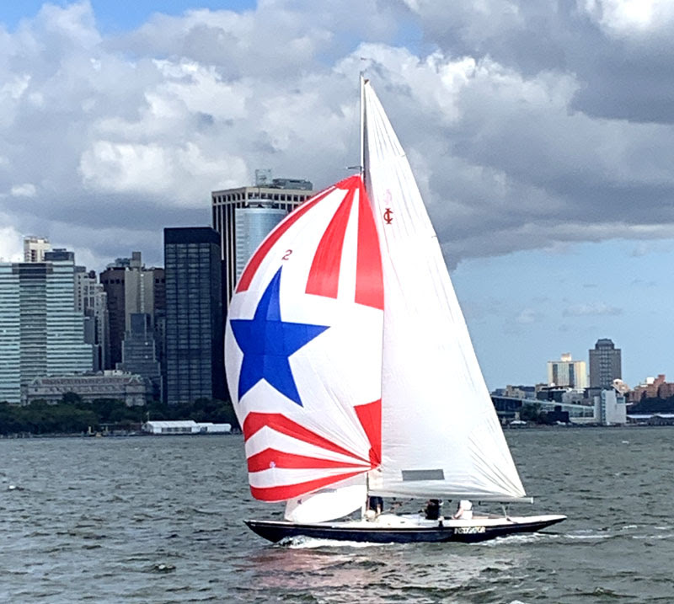

**MARBLEHEAD 2020**

The Marblehead Fleet was inactive in 2020. COVID restrictions limited club use (and launch use) to club members only. And only two passengers were allowed in each launch trip. These health restrictions effectively made it impossible to sail or race IODs, it was a summer for the dinghies...

The Fleet suspended operations, including racing and social events, and opted to cancel dues payments from non-owners. Some owners used the time (and the extra time at home) to work on their boats, some boats remained covered for the summer. Only one boat launched.

Following the IOD Worlds in 2019, IOD #51, Sagacious, a beautiful original 1936/7 hull, was sold to the Chester fleet. We were sad to see her go, but we know she is in good hands.

Moorings in the main harbor continue to be a significant barrier to Marblehead Fleet development. (mooring cannot be sold with a boat, so any new owner must have access to a main harbor mooring or be forced to moor their boat in a secondary anchorage that is 45-60 minutes farther away from the racing area. To try to address this critical need, the Marblehead Fleet recently incorporated as an LLC, which has allowed us to apply for moorings in Marblehead in the fleet’s name. It will be many years before we obtain these moorings, but while we are on the waiting list, we are able to apply for temporary moorings, which may help one or two of our owners each season. (temporary moorings are only rarely granted)

We look forward to be back at it – weather and COVID permitting, in 2021.

Submitted by: Greg Mancusi-Ungaro, Fleet Captain.

**NORTHEAST HARBOR 2020**

The 2020 IOD Class season began as others in the past with early planning discussions around topics identified by members in our 2019 late summer meeting. Several key items included a more user friendly schedule that would allow for options to maintain a competitive season schedule with flexibility to pursue family or flex time with less impact to qualifier participation, as well as explore alternative local regatta events. This would be achieved by modifying our discard schedule, and having open days normally reserved for qualifier racing.

The Input process on the approaching season was expanded with initiatives by the Fleet officers and management which enabled detail feedback and discussions involving the core racing entities, PHRF, IOD, and Luders classes, along with fleet operations and the Sailing School. We’re thankful that our racing entities have access, participate, and can add value to so many elements involved in the Fleet deliverables of racing and water access, as well as our larger community of Fleet members and interrelated operational activities.

Planning discussions began early in the year, and by March, had taken on a completely different focus. We were all facing a season that may not have been. The Flag officers and Fleet management considered all options as research and evaluation of large professional environments as well as small, localized and isolated venues were evaluated with our own fluid outline of what we could accomplish with safety and inclusion as key priorities for services, if any, that could be provided to Fleet members.

The IOD Class co-developed and agreed on measures for the season. Reduced crew numbers and parameters to begin the season were adopted along with mask protocols. Fleet property, launch, and racing safety protocols were in effect all season. In addition, a contact tracing doc was completed every race day and additional safety and low touch social distancing rules were followed by all crews. The result of our pivot, due diligence, inclusive leadership, and blessed with an intimate venue and good weather, allowed us to have a fortunate season that extended through September.

Strong participation was evident with two traditional full months completed (our normal qualifier series) in July and August. 16 different boats came to the line in July for 12 races, and 19 different boats for 11 races in August. Every race saw well over 10 boats starting. Participation was also strong for the 4th of July; 9 boats, and Labor Day Series; 11 boats. Franny and Sue Charles provided excellent race management while 2-handing 2020’s modified low touch on-water Race Committee procedures. A high level of competition was not compromised by crew adjustments relative to limits and individual schedules disrupted this season.

Noteworthy performances for 2020 were highlighted by Sofie Dowling leading a youth team developing over the past several years schooling the old guard with a strong 3rd against 16 in July and 3rd against 19 in the August series. Our high school and college sailor’s participation on many teams continues to grow and they’re displaying a high level of talent and competition. John Henry took honors for July and August (with co-skipper Tyler Steel in August). Steve Madeira won the Labor Day series and took 2nd behind John for the July 4th series. Additionally, Sydney Rockefeller won the annual Eggemoggin Reach Regatta in Brooklin, ME.

To our larger IOD World family, the Northeast Harbor Fleet IOD Class wishes all a safe and healthy future and looks forward to seeing you on and off the water when our special gatherings resume.

On behalf of the IOD Class Officers and the Northeast Harbor Fleet

Best Regards,

Rick Echard

IOD Class Captain

**NANTUCKET 2020**

Regrettably there was no IOD sailing on Nantucket in 2020.

Throughout the spring, the NIODFA Board postponed the decision to launch boats as long as possible. By early June the Nantucket Invitational was cancelled and launchings were postponed until July. However, as the State of Massachusetts restrictions related to the Covid 19 virus persisted, it became clear that racing would be difficult at best and restrict many syndicates from participating at all.

In fairness to all Association syndicates, no boats were launched.

The Association very much looks forward to the 2021 season as a return to normalcy and the reinstitution of our Nantucket Invitational on June 25 and 26. To that end social distance, wash hands and wear a mask.

With Best Wishes to all our IOD Friends for a Healthy New Year on the water,

Geoff Verney

Fleet Captain, NIODFA

**NORWAY 2020 – Fredrikstad & Tonsberg**

A very strange 2020 season for all IOD fleets, and so also in Norway.

Spring and first half of the summer without any activity on the water for the IOD Fleet, but some of the teams managed to arrange some training with limited crew numbers on the boat.

And 3 IOD´s was participating in the KTK-Classic Regatta at Hankø in the start of July together with a hole fleet of R-yachts R6, R8, R9, R10 and R12, and some other smaller and larger Wooden yachts.

N2 Tina with Espen Eggen and his crew in first place, followed by R8 Wanda, and N30- Ivory

After the summer vacation Tønsberg IOD Fleet together with Tønsberg Yacht Club

Invited to Class championship in IOD´s, but with limited crew (3 persons).

N67 Blues, N63 Kaia III, N50 Kaia II, N14 Veslemarit, N2 Tina, N30 Ivory participated in

This Regatta, and everyone was very keen to do their best on and off the water.

5 races were arranged, and Martin got together an aftersail on Saturday with Pizza & Beer

At the Yacht club with social distance almost the whole evening.

Short course and tight racing was seen throughout the weekend, and in the last race

It ended the season for Kaia III and Kaia II with a classic T-bone at the start.

Luckily no one got injured!

Results:

1. Martin Rygh - N67 Blues – 5 points
2. Gustav Rygh - N63 Kaia III – 8 points
3. Tormod Lie - N30 Ivory – 8 points
4. Espen Eggen – N2 Tina – 15 points
5. Leif Skorge – N14 Veslemarit – 18 points
6. Mai Britt Ingebrigtsen– N50 Kaia II – 23 points

News from The fleet.

N14- Veslemarit New owner- Leif Skorge

Home harbor Kjærringvik – (Tønsberg Fleet) Photo below.

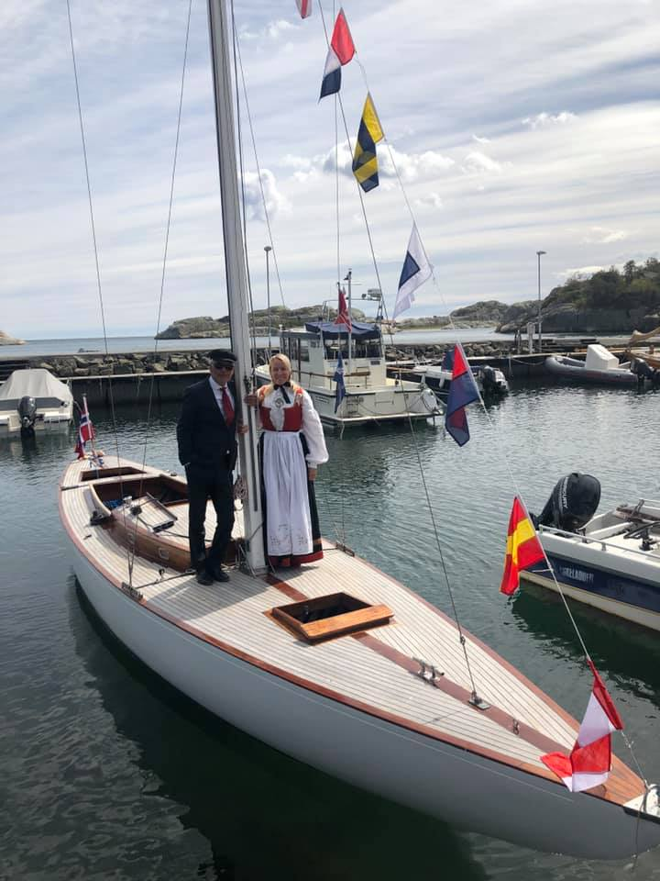

N24 has been stranded on shore for the last years, but is now sold to

Linda Rui and Håkon Honningsvåg, and they were also participating in the Classic Regatta on Hankø in July. Home harbor will be Oslo. Photo below.

N50- Kaia II, was sold from Gunhild Rosnes and Kai-Egil Olsen to an All-Girls Team,

with Mai Britt Ingebrigtsen as Skipper.

Home harbor will be Fredrikstad / Hankø

N54- Era (previous S54- Swea) is home from Sweden with new owner

Knut Chr Hallan from Son.

Home harbor will be Son. Photo below.

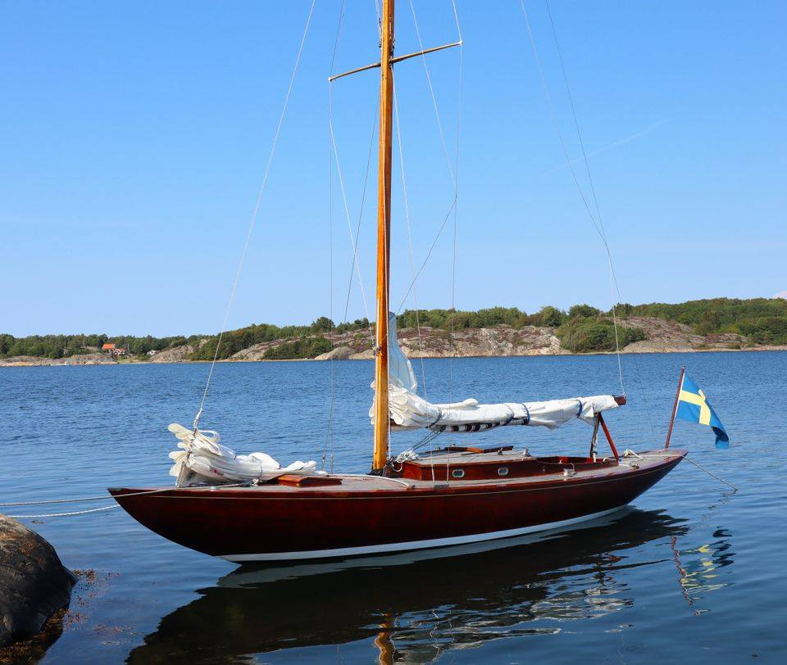

Hopefully we will be Racing more in 2021, and we wish all IOD Fleets and Sailors the best of luck for next year.

Best regards, Tormod Lie Feet Captain, IOD Fleet Norway

**SAN FRANCISCO 2020**

In the midst of the COVID calamity, political dystopia and seemingly never-ending threat of fire, sailing IOD’s on San Francisco Bay remains the respite for most members and has further united the SF IOD Fleet.  Nothing says “trust, commitment and community” better than a “social bubble,” and despite our reputation for disharmony, the SF IOD Fleet continues to find sanity and clarity in the simple acts of sailing to windward and sharing a dark and stormy.  Local yacht clubs called off nearly all events for the summer, but several of us made a practice of regularly meeting mid-bay and chasing around some buoys.  It has been good for the boats, good for the kids and good for the soul.  And we have very much enjoyed connecting with our friends around the world over social media.  How wonderful it is to share the same antidote to the various versions of 2020 craziness!  And while the news is dominated by protesters and peacekeepers competing to claim victimization, and our cherished sailing organizations have not been immune from these trends, the SF IOD Fleet continues to build community from our shared values, our shared history and our shared commitments.  We look forward to a 2021 that is even brighter.

Paul Zupan  
SF Fleet Chairman

**SWEDEN 2020**

This has been a strange year for all of us, the covid pandemic is putting road blocks every were. But were there is a roadblock, there is a detour.

We have been able to sail the series and the class races as planed. But has not been allowed to arrange the Pater noster Race as we use to. We did however get allowed to sail the Tjörn runt race, but they were not allowed to have a price giving ceremony.

The weather has been unpredictable as usual here in both the spring and autumn series.

Some of the times all crews has been standing on the dock ready to go out for a sail but has been forced to go home again due to to strong winds, and sometimes all boats has been towed out to the starting area and waiting all day for some wind to come along and let us sail a little, but no we just had to be towed back home again.

Even so we also have had some fantastic sailing and have all in all had a great season, no major accident and a lot of good competition on the starting line.

The Swedish fleet now consists of 12 boats, there of one with all female crew,

and two boats with young crew all under 25. These boats are sponsored by IOD fleet Sweden under a 3-year period and has been a success. We now have one more crew that are interested in a boat if we find one. This possibility for young crew is something we consider continue with to get more new crews an a somewhat lower average age in the fleet.

Lars is as always working hard to get more boats in the fleet and has now great help from Robin, scanning the market for any thing that can be added to the fleet including building new once boat #73 is now in the moulds and are expected to be ready for 2021 season.

Best regards

Reine Larsson

President IOD Fleet Sweden